Software Development for Mobile Devices

# Submission for Assignment A2.2P

## Task 2. Orientation State

### Why the time information updates when orientation changes

When the activity launches, it firstly calls method onCreate() to setup a view. Thereafter, the method initializeUI() is called to get the current time as it is called within onCreate().

In this case, when the users change the orientation, the view must be created to display the correct orientation to users. Hence, the method onCreate() is invoked again and the time is updated.

|  |  |
| --- | --- |
| Portrait | Landscape |
| ../../../../../../../Desktop/Screenshot_153328 | ../../../../../../../Desktop/Screenshot_153328 |

### The difference between Resume, Pause and Stop states.

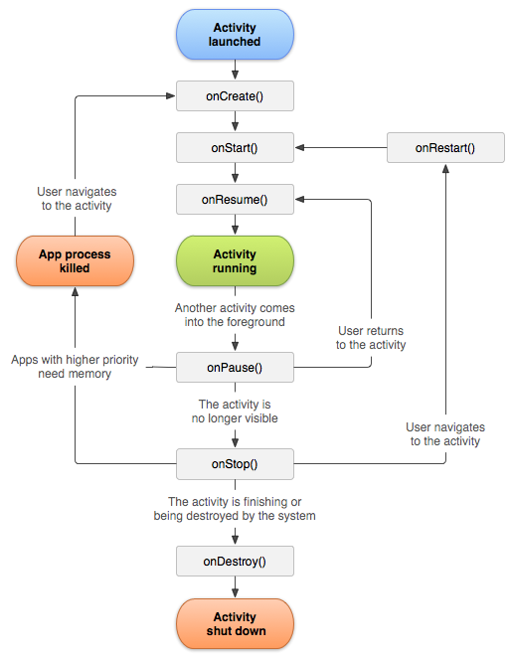

Figure : Android life cycle

This image is from (Understand the Activity Lifecycle 2018)

### Resume

The Resume state is started when the activity goes to the foreground. Then the system fires the method onResume() callback. The users interact with the application in this state. Besides, if users return to the application from interruptive event, the activity will enter this state.

### Pause

In case of any interruptive event occurs, the activity will enter Pause state and also the onPause() method is called by the system. This state illustrates that the activity is no longer in the foreground but it can be seen in a multi-window mode.

### Stop

When the activity cannot be seen in the foreground and is likely to be terminated, it will enter Stop state and the system will call the onStop() method. In this state, the memory is not fully cleared and it may also come back to interact with the users after calling onRestart().

# References

*Understand the Activity Lifecycle*, viewed 15 August 2018, <https://developer.android.com/guide/components/activities/activity-lifecycle>.